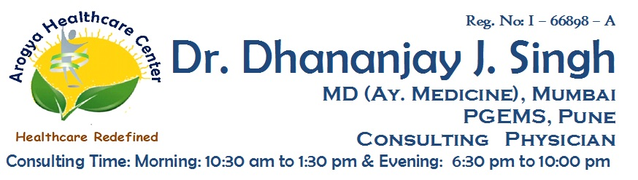

**Reg No: I-66898-A**

**Dr. Dhananjay J. Singh**

**MD (MEDICINE AY.) MUMBAI, PGEMS CONSULTING PHYSICIAN**

Date : / /202

**MEDICAL CERTIFICATE**

**To Whomsoever It May Concern**

**Dr. Dhananjay J. Singh**

**Address :** Shop No:3, Redwood Building, Orchid Residency, Charnipada, Bhiwandi, Dist - Thane